Design:
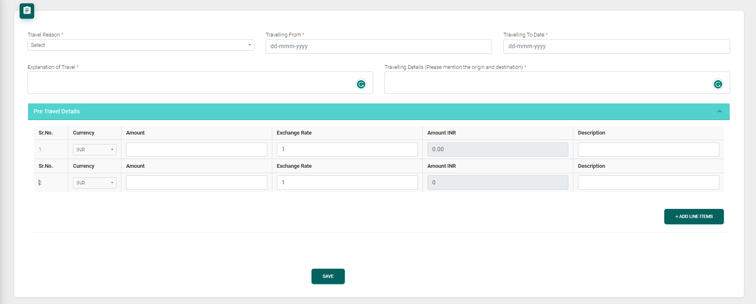
Description:
Create a web form using MVC C# that allows users to input travel details similar to the above screen.
Upon clicking "Add Line Items," a new row should be generated in the Pre-Travel Details table.
The user will select a currency, enter an amount, and an exchange rate, based on which the INR amount should be calculated.
For instance, if the user chooses USD in the dropdown, inputs 1000 in the amount textbox, and enters 80 in the exchange rate, the INR amount should be 80000.
When the user clicks on the save button, the travel details including the Pre-Travel details, should be saved.
Additionally, the user should be able to view, insert, update, and delete the travel details.
Good to have:
Delete option in the Pre-Travel details table
Estimated Time:
5 Hours

